**TEAM**

**25**

**Stock Price Prediction**

**Team**

**Architecture**

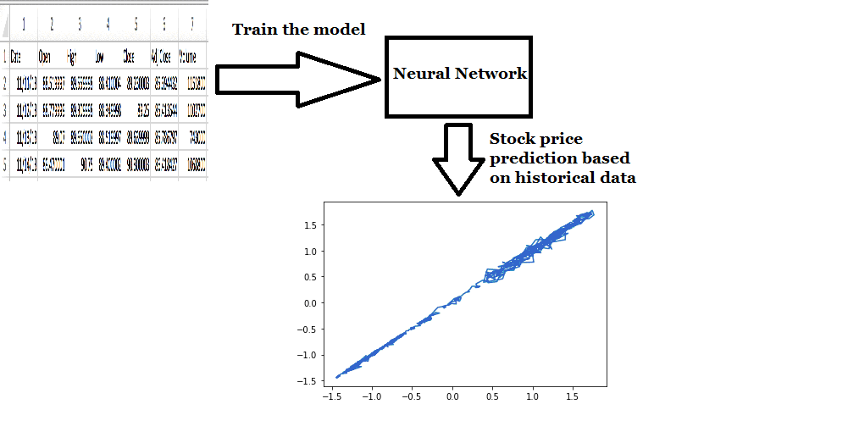

**Modules**

Choosing the model

Training the model

Testing the model

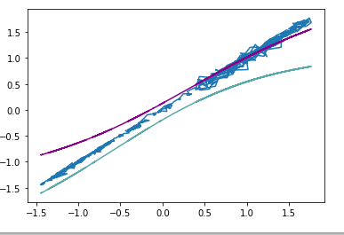

**BVRIT HYDERABAD**

**College of Engineering for Women**

**Department of Information Technology**

**Mini Project - Academic Year 2018-19**



**Tools and Technologies**

* **Python 3.6**
* **Matplotlib**
* **Tensorflow**
* **Sckit-learn**
* **Numpy**

**Conclusion and Future Scope**

By using this model we can know the price variations of a particular company on a particular day starting from opening to closing. We have represented it using graph by taking dates on x-axis and price on y-axis. To check the model whether it is accurate prediction or not we decrease the error tolerance and see the changes in the graph.

**Guide**

**Dr. K Adi Narayana Reddy**

**Professor of IT**

**adinarayanareddy.k@bvrithyderabad.edu.in**

**Abstract**

Stock Price Prediction is the act of trying to determine the future value of a company stock or other [financial instrument](https://en.wikipedia.org/wiki/Financial_instrument) traded on exchange. The successful prediction of a stock's future price could yield significant profit. The [efficient-market hypothesis](https://en.wikipedia.org/wiki/Efficient-market_hypothesis) suggests that stock prices reflect all currently available information and any price changes that are not based on newly revealed information thus are inherently unpredictable. Others disagree and those with this viewpoint possess myriad methods and technologies which purportedly allow them to gain future price information. The [efficient market hypothesis](https://en.wikipedia.org/wiki/Efficient_market_hypothesis) posits that stock prices are a function of information and rational expectations, and that newly revealed information about a company's prospects is almost immediately get reflected.

**Web 2.0 technologies made users to spend more time on the Internet to search for answers about various questions.**

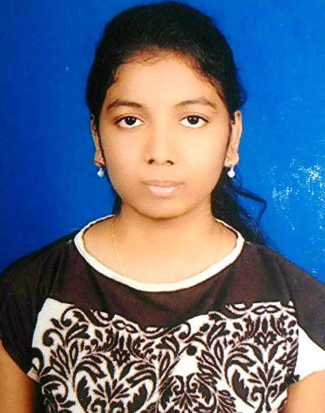

**16WH1A1226 16WH1A1248**

J. Nicole V.Bhanu Samera

**Samera**